**WAL**

WAL stands for Write-Ahead Logging. It is the standard protocol being used to ensure that all the changes made to the database are being logged properly in their order of occurrence. It helps maintain data integrity by facilitating a recovery process in the case of a database crash.

WAL is enabled in PostgreSQL by default and has a default size of 16MB.

One major advantage of WAL is that it supports online-backup and point-in-time recovery.

**Replication**

Replication it creates a replica of one database in another. Both these databases are usually located on different physical servers .

Replication is implemented in PostgreSQL using a master-slave configuration. The master acts as the primary instance and is responsible for handling the primary database and its operations. The slave acts as the secondary instance and implements all modifications made to the primary database on itself, thus making itself an identical copy. The master is the read/write server whereas the slave is a read-only server.

**Prerequisites**

* Working knowledge of PostgresSQL.
* PostgresSQL installed on the host workstation

**Postgres WAL Replication**

WAL helps to replicate data between the database servers in two ways:

• File-Based Log Shipping

• Streaming WAL Records

* **File-Based Log Shipping**
* 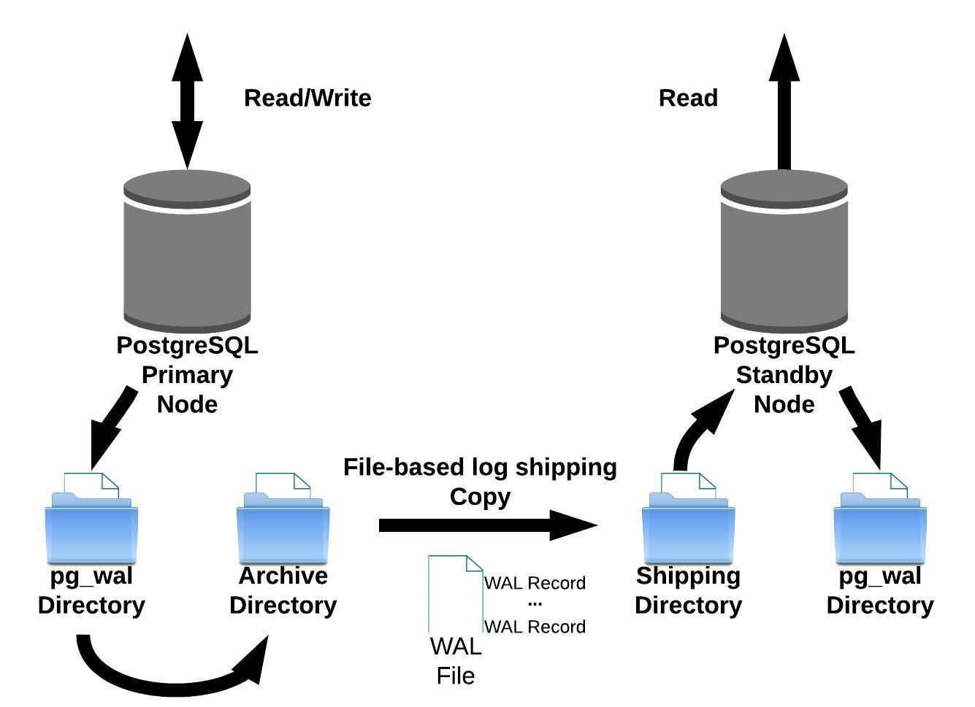

All WAL logs have a maximum storage capacity of 16MBs and are shipped only after they reach the threshold value. This can cause a delay in the replication process and increase the chances of a data loss due to a possible master crash.

**Streaming WAL Records**

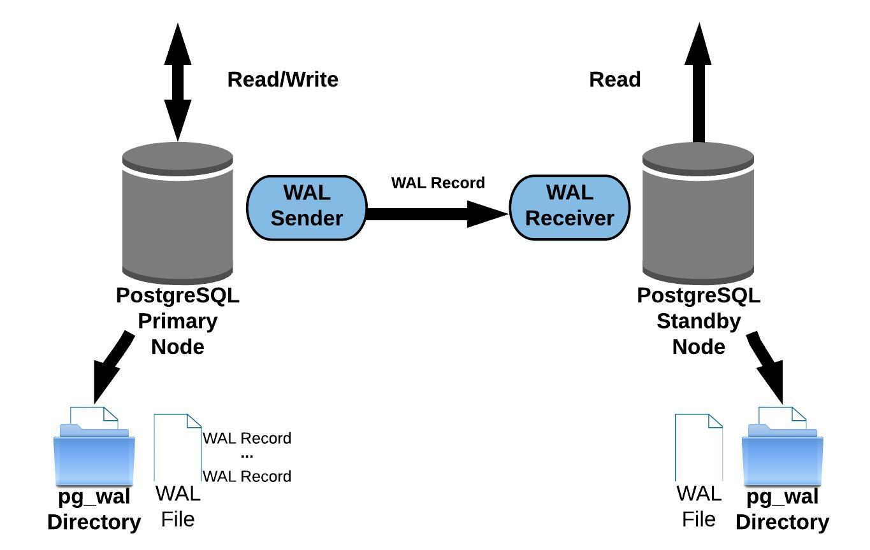

The database servers stream WAL records in chunks to ensure that the data is always in sync. The slave servers receive the WAL chunks by establishing a connection with the master server. The advantage of streaming WAL records is that it doesn’t wait for the capacity to be full, these are streamed immediately. This helps in keeping the standby server up-to-date.

**Configuring Master Node**

The master node can be configured using the following steps:

• Step 1: Database Initialization

• Step 2: Creating A New User

• Step 3: Configuring Streaming Properties

• Step 4: Replication Entry In pg_hba.conf File

**Configuring Standby Node**

Once the master node is configured, the next step for Postgres WAL replication is to configure the standby node. You can configure the standby node in two simple steps:

• Step 1: Create A Backup Of The Master Node

• Step 2: Creating The Replication Configuration File